WEB TECHNOLOGIES (4.5CA152C01)

ASSIGNMENT - II

**Q.1: What does CSS stand for ? Name three types of CSS. List three common properties used in CSS for styling text.**

Ans: CSS stands for Cascading Style Sheets. Three common properties used in CSS for styling text are listed as-

1. Text properties
2. Border properties
3. Font properties

**Q.2: Explain the difference between internal, external, and inline CSS.**

Ans: INTERNAL CSS : Internal CSS, also known as embedded CSS, involves adding CSS rules directly within the <style> element in the <head> section of an HTML document. It allows styling specific to that document.

EXTERNAL CSS : External CSS is used to place CSS code in a separate file and link to the HTML document. To use external CSS, create a separate file with the .css file extension that contains your CSS rules. You can link this file to your HTML document using the “link” tag in the head section of your HTML document.

INLINE CSS : Inline CSS is a way of defining the styling of an HTML element by adding CSS rules directly to the element’s tag using the “style” attribute. It is used for quick and simple styling changes to specific elements, without creating a separate CSS file.

**Q.3: How does the position: absolute differ from position: relative?**

Ans: Position: Relative is positioned relative to its normal position and the Position: Absolute is positioned absolutely to its first positioned parent.

**Q.4: Describe the difference between id and class selection in CSS.**

Ans:

|  |  |
| --- | --- |
| **CLASS** | **ID** |
| We can apply a class to various elements so that it could be numerous times on a single page. | The Id is unique in a page, and we can only apply it to one specific element. |
| The class is assigned to an element and its name starts with "." followed by the name of the class. | The name of the Id starts with the "#" symbol followed by a unique id name. |
| We can attach multiple class selectors to an element. | We can attach only one ID selector to an element. |

**Q.5: Use CSS to create a hover effect that changes the text color of a button when a user hovers over it.**

Ans:

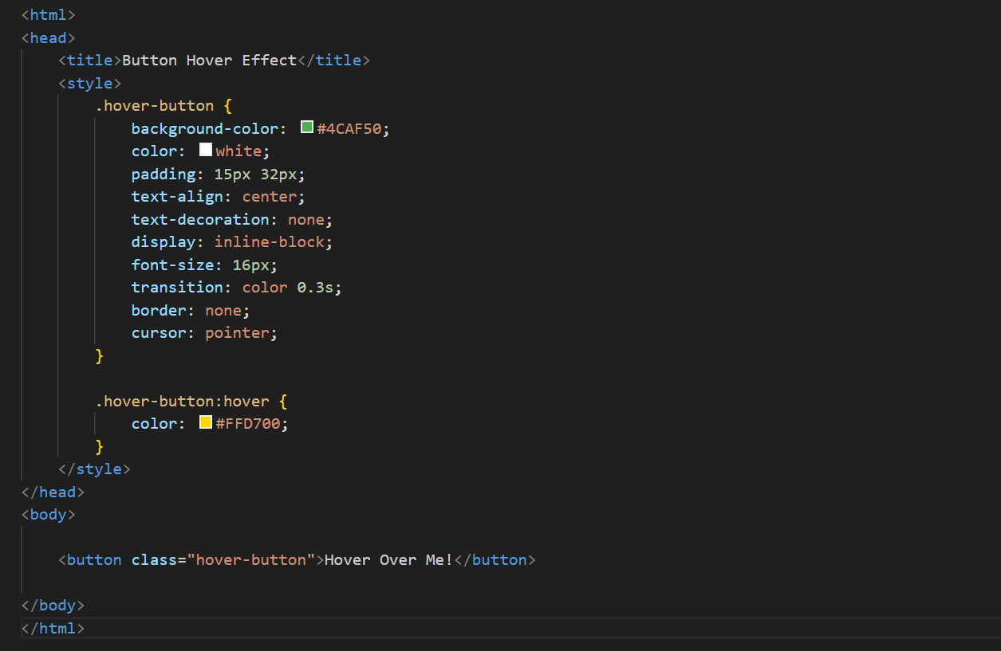

**Q.6: Style a form using CSS so that the input fields have a specific width, border color, and padding.**

Ans: 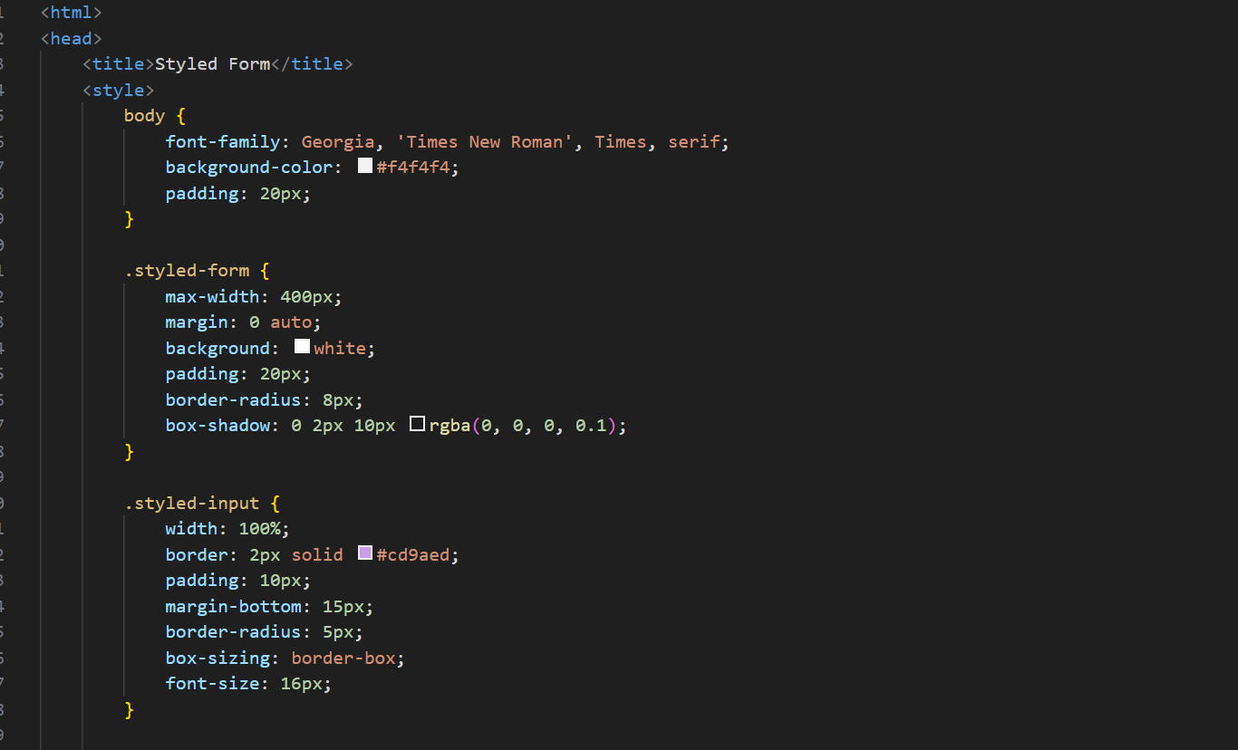

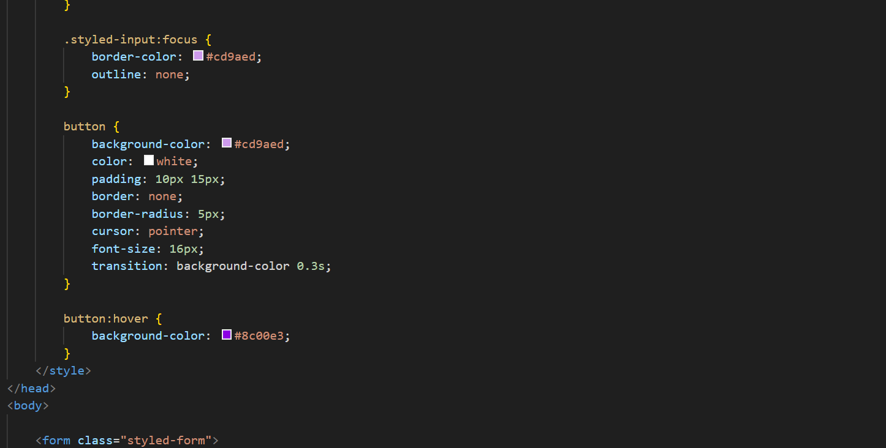

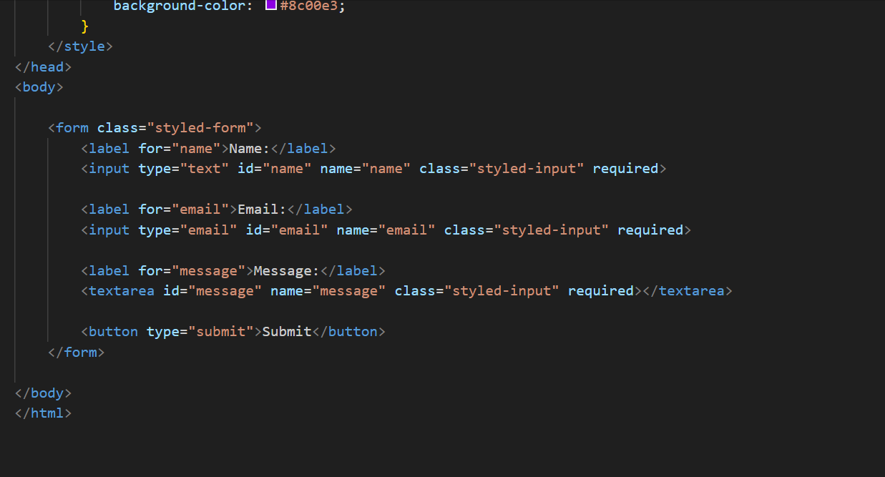

**Q.7: Break down the structure of a CSS rule and explain each part of it.**

Ans: Selector (h1): Identifies the HTML element(s) that the style applies to (in this case, all <h1> elements).

Property (color): Specifies the attribute of the element that you want to style, such as color, font size, or margin.

Value (blue): Defines the specific setting for the property. Here, it sets the text color to blue.

Example:

h1 {

color: blue;

}

**Q.8: Construct a CSS style sheet for a form that uses advanced selectors, pseudo-classes and media queries.**

Ans:

